

Marmara University
Faculty of Engineering

PHYS 1104
PHYSICS LABORATORY II

Capacitor Charge and Discharge

Section:
Group:
Instructure: Date:
 | Department | Student Id Number | Name & Surname
1
2
3

Purpose
To observe the effects of capacitance, resistance and voltage on the charging of a capacitor in an $RC$circuit.

Theory
Basically, a capacitor can be built by placing two metal conductive plate face to face in a small distance (Figure 1). Then the plates are connected to a voltage source and when the potential is applied one of the plates are charged $(+) Q$, while other is $(–) Q$. The voltage difference between the two plates are approximately equal to the applied voltage. Capacitance is the ratio of the charge to the potential difference between the plates. It is shown by $“C”$ with a unit of $Farad (F)$ which is in SI unit system.
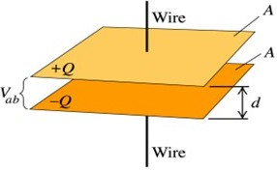 | 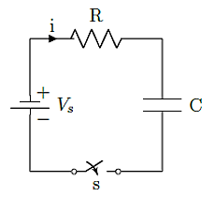
Figure 1 Parallel plate capacitor. | Figure 2 Capacitor charging circuit diagram

In the circuit of Figure 2, the change with time of the current passing through the charging capacitor (C) which is connected in series with the resistor (R) with applied a constant voltage (V) is given as follows:
$I\left(t\right)=$ $\frac{V_{s}}{R}$ $e^{-\frac{t}{RC}}$ (1)
Where, Vs is the source voltage, R is the resistance, Vc is the voltage on capacitor.
The RC time constant (τ) is the time it takes for a capacitor to charge or discharge through a resistor. It is calculated by multiplying the resistance (R in ohms) by the capacitance (C in farads). The value of the time constant is %63.2 of the maximum voltage applied to the capacitor.
The Equation 1 can be represented in terms of time constant (τ).
$I\left(t\right)=$ $\frac{V_{s}}{R}$ $e^{-\frac{t}{τ}}$ (2)
$V_{c}=V_{s}(1-e^{-\frac{t}{RC}})$ (3)

In the case of discharging of the capacitor voltage and current are calculated by
$I\left(t\right)=$ $-\frac{V_{s}}{R}$ $e^{-\frac{t}{τ}}$ (4)
$V_{c}=V_{s}e^{-\frac{t}{τ}}$ (5)

Experimental Setup

Equipment List
- Board x1 | - DC Voltage Source (0 – 30 V range) x1
- Digital Multimeter x2 | - On-off switch x1
- 1000 µF Capacitor x2 | - Connection cables
    - 10 kΩ Resistor x1
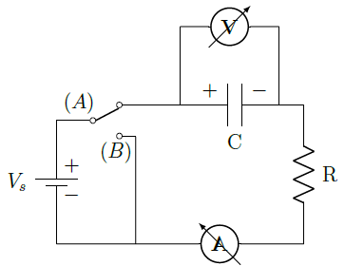
Figure 3 Circuit diagram
The experimental setup is shown in Figure 3. The internal resistance of the digital multimeter and the setting time can be disregarded. R is a protective resistor that limits the current while discharging the capacitor when Switch is set to B.
In this experiment, you will record the voltage across the capacitor and current passing through the circuit as a function of time for different values of the capacitance and the source voltage. To observe the theoretical relation given in Equation 1, it is best to graph natural logarithm of the current as a function of time. In that case, the theoretical expression can be written as
$\ln{I}=\ln{(\frac{V}{R})}-\frac{1}{τ}t$ (6)
The slope of the plot of Equation 6 is $-\frac{1}{τ}$. The intersection point of the plot on y axis is $\ln{\frac{V_{s}}{R}}$.

Procedure
- Ensure that the capacitor and resistance are working properly. Check with multimeter.
- Adjust the voltage source to the desired value precisely and ensure that it works correctly using a digital multimeter.
- Build the circuit shown in Figure 3 but be careful the minus part of the capacitor should be plugged in the correct direction of the current. If it is plugged in a wrong way, the circuit does not work as requested. Be careful your circuit must be similar to the Figure 4 showing all connection and Figure 5 showing the detail view of the circuit.
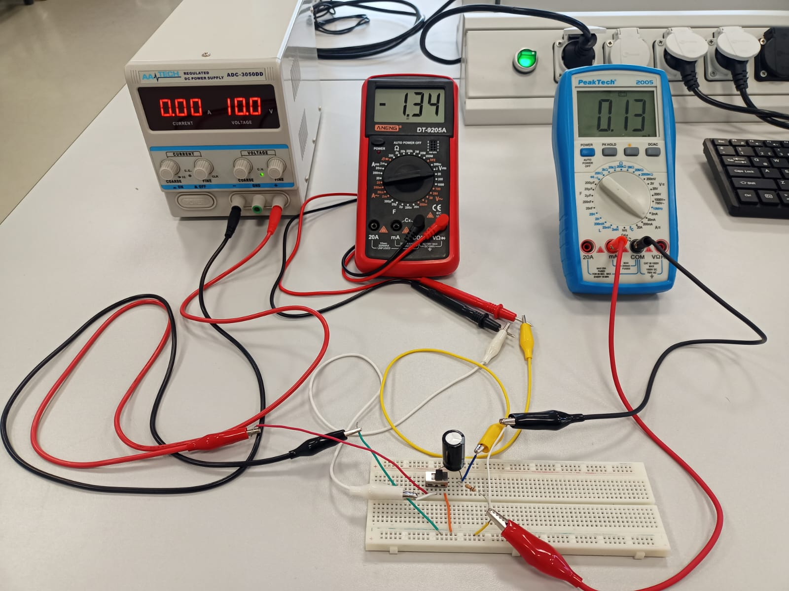
Figure 4 Experiment setup
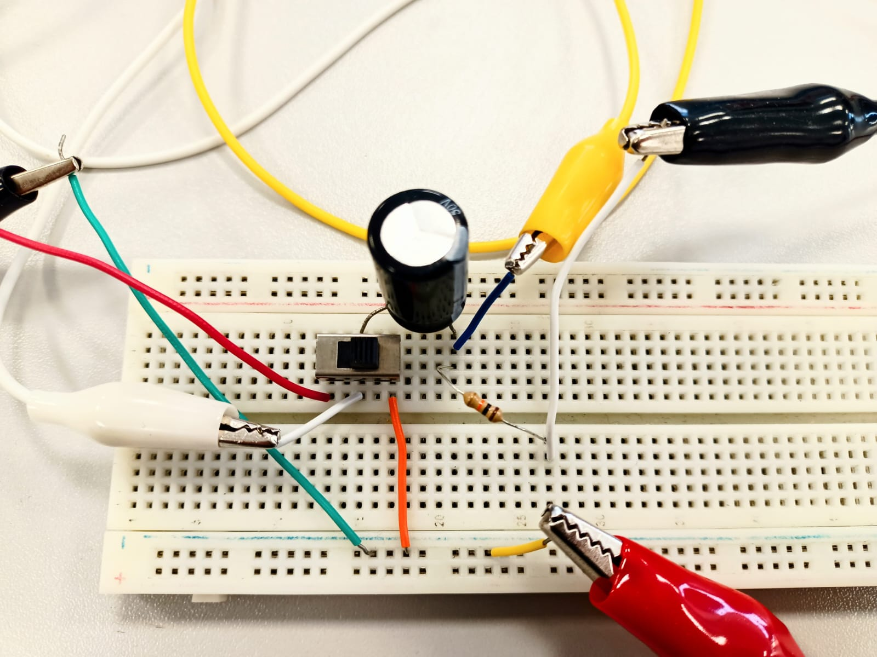
Figure 5 Detail view of the circuit
- Take the video covering the beginning and end of the experiment for each part. The screens of the power supply and both multimeters should be visible on the frame of the recorded video. The video must be taken without shaking video camera.
- Write the voltage and current values in the frames corresponding to the time in the related tables. (you can obtain these values by writing them to a file using image processing and OCR programs)
- Plot voltage vs time and Iexp vs time graphs for each case.
- Calculate the theoretical values of the time constants $(τ)$ for all parts. Determine the experimental values of the time constants by drawing the ln (I_{exp}) vs time graph. The slope of the graph will be $-\frac{1}{τ}$ as shown in Equation 6. Determine the percentage error of time constant.
- Follow steps from 5 to 7 for each part with the values given in the Table 1
- Before charging the capacitor ensure that the capacitor is fully discharged by changing the switch to the position of B.
- Write the time, current and voltage values of Part I, Part II and Part IV in Table 2, the values of Part III in Table 3.
- In Table 5 calculate percentage errors of voltage, resistance and capacitor values used in the Part I to Part IV. The row named 3.A and 3.B are values depend on charging and discharging capacitor of the circuit in Part III respectively.

Table 1 Value of source voltage, resistor and capacitor of each part
Part | V_{s} (V) | R (kΩ) | C (µF)
I | 10 | 10 | 1.000
II | 10 | 20 | 1.000
III | 10 | 20 | 2.000
IV | 5 | 20 | 2.000

Data Table
Table 2. Recorded values of voltage and current of Part I, Part II and Part IV
Part I.  R₁=10 kΩ, C₁=1000 μF |  |  |  | Part II.  R₂=20 kΩ, C₁=1000 μF |  |  |  | Part IV.  R₂=20 kΩ, C₂=2000 μF
Time (s) | $I$ (mA) | $V_{c}$ (V) |  | $V_{c}$ (V) | $I$ (mA) | $V_{c}$ (V) |  | Time (s) | $I$ (mA) | $V_{c}$ (V)

Table 3., Charge and discharge
Part III. R₂=20 kΩ, C₂=2000 μF
- Charge |  |  |  | - Discharge
Time (s) | $I$ (mA) | $V_{c}$ (V) |  | Time (s) | $I$ (mA) | $V_{c}$ (V)

Table 4. % error of time constants
Part | Value of Voltage, Resistance and Capacitor |  |  | Time constant $(τ)$
Part |  |  |  | Theoretical | Experimental | % error
1 | V₁: | R₁: | C₁:
2 | V₁: | R₂: | C₁:
3.A | V₁: | R₂: | C₂:
3.B | V₁: | R₂: | C₂:
4 | V₂: | R₂: | C₂:

